
©2006 www.firstschoolyears.com
©2006 www.firstschoolyears.com
©2006 www.firstschoolyears.com
©2006 www.firstschoolyears.com
©2006 www.firstschoolyears.com
©2006 www.firstschoolyears.com
©2006 www.firstschoolyears.com
©2006 www.firstschoolyears.com
Time Cards
Time Cards

Time Cards

Time Cards

Time Cards

Time Cards

Time Cards

Time Cards

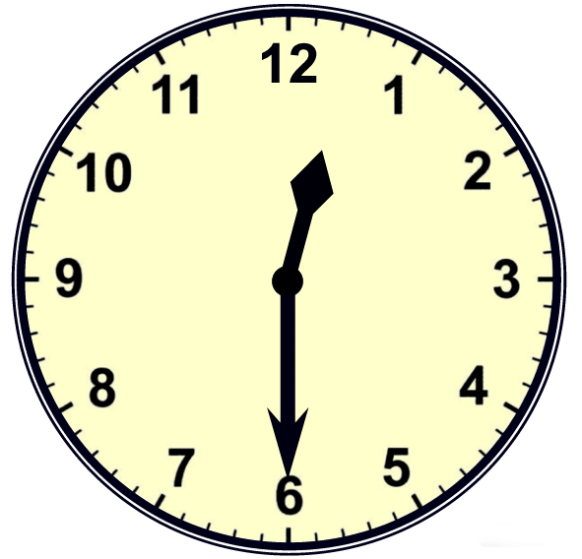
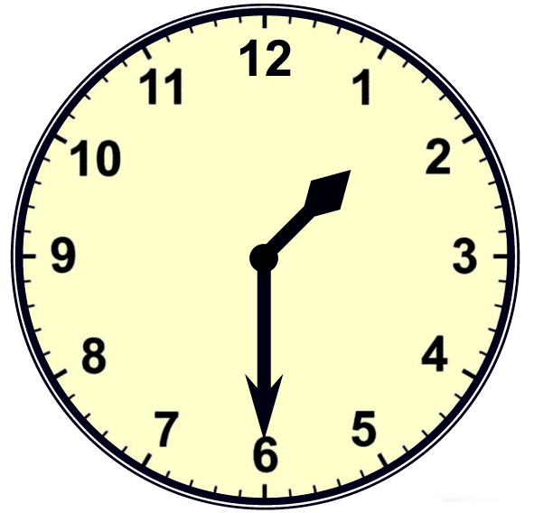
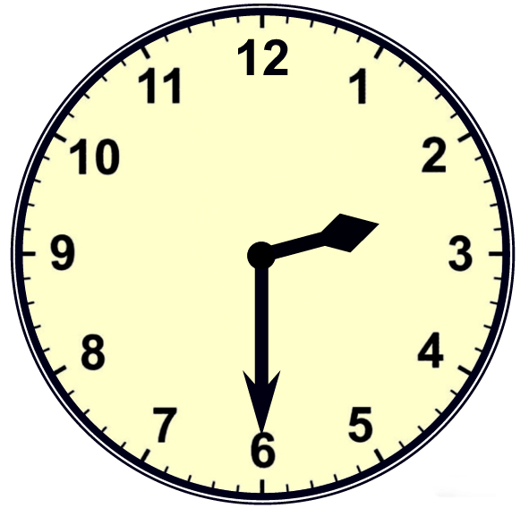
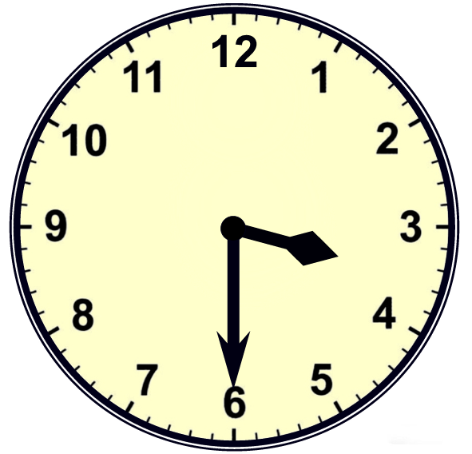
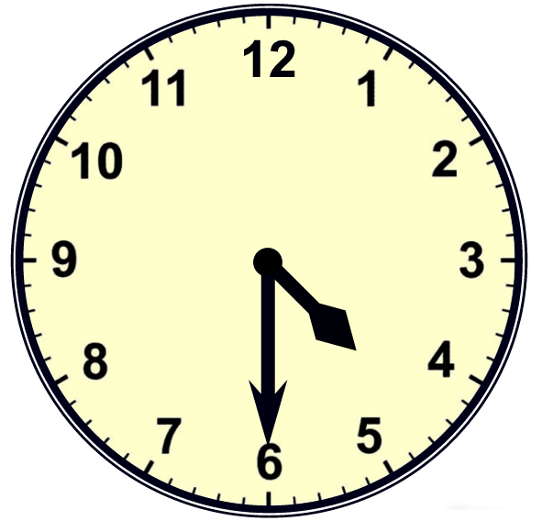
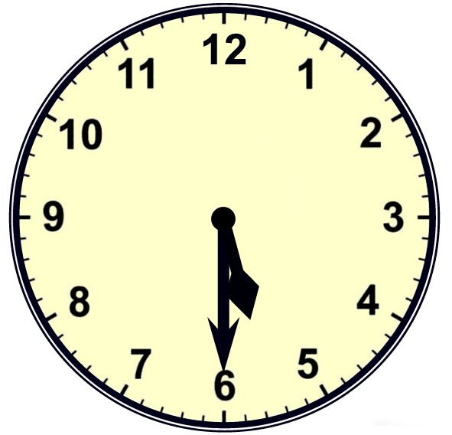
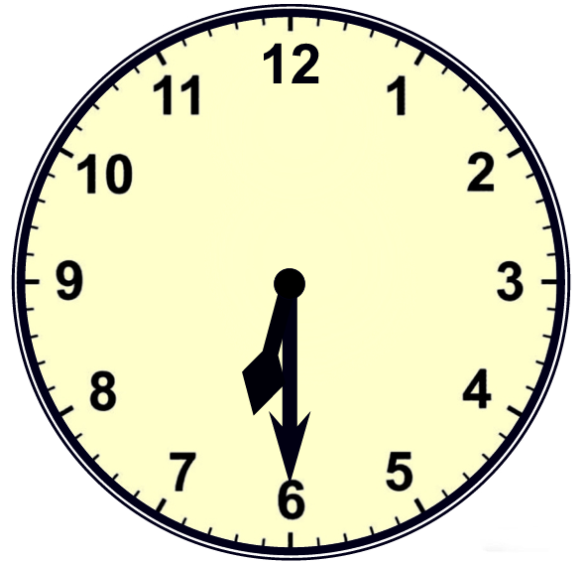
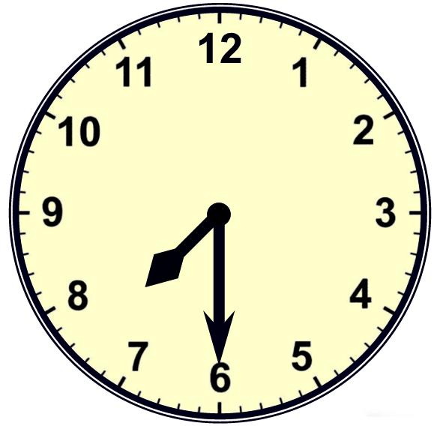
©2006 www.firstschoolyears.com
©2006 www.firstschoolyears.com
©2006 www.firstschoolyears.com
©2006 www.firstschoolyears.com
©2006 www.firstschoolyears.com
©2006 www.firstschoolyears.com
©2006 www.firstschoolyears.com
©2006 www.firstschoolyears.com
Time Cards

Time Cards

Time Cards

Time Cards

Time Cards

Time Cards

Time Cards

Time Cards

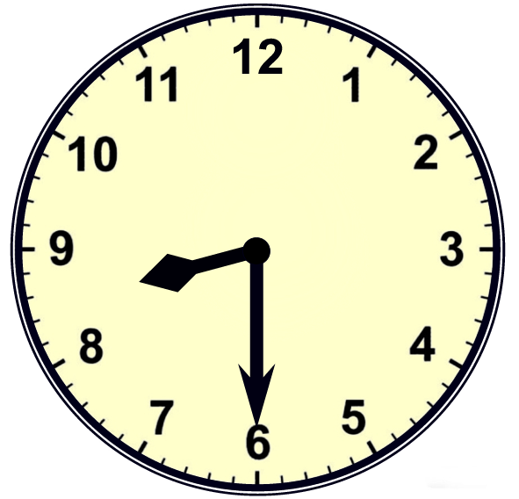
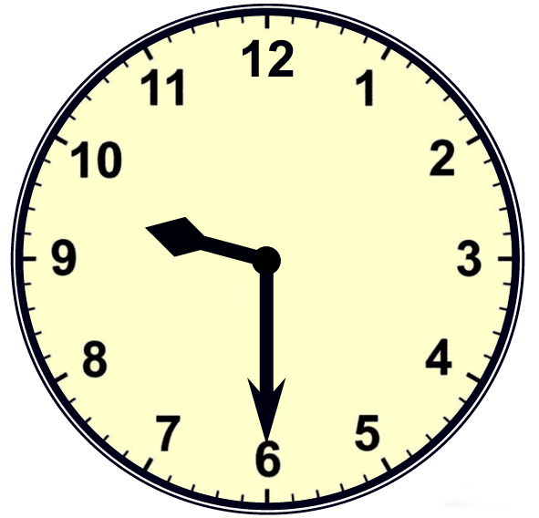
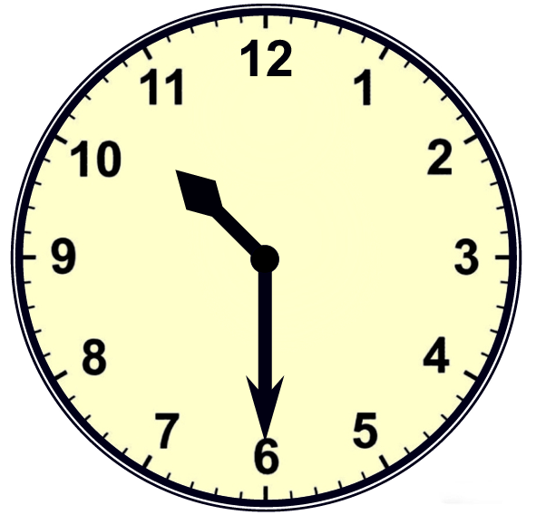
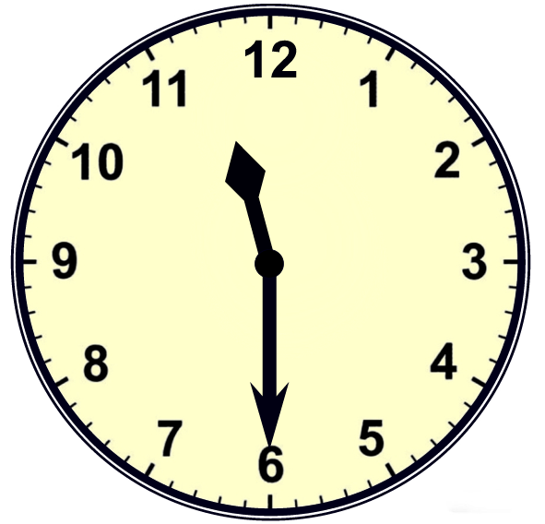




©2006 www.firstschoolyears.com
©2006 www.firstschoolyears.com
©2006 www.firstschoolyears.com
©2006 www.firstschoolyears.com
©2006 www.firstschoolyears.com
©2006 www.firstschoolyears.com
©2006 www.firstschoolyears.com
©2006 www.firstschoolyears.com
Time Cards
Time Cards
Time Cards
Time Cards
Time Cards
Time Cards
Time Cards
Time Cards








©2006 www.firstschoolyears.com
©2006 www.firstschoolyears.com
©2006 www.firstschoolyears.com
©2006 www.firstschoolyears.com
©2006 www.firstschoolyears.com
©2006 www.firstschoolyears.com
©2006 www.firstschoolyears.com
©2006 www.firstschoolyears.com
Time Cards
Time Cards

Time Cards

Time Cards

Time Cards

Time Cards

Time Cards

Time Cards

half past 12
half past 1
half past 2
half past 3
half past 4
half past 5
half past 6
half past 7
©2006 www.firstschoolyears.com
©2006 www.firstschoolyears.com
©2006 www.firstschoolyears.com
©2006 www.firstschoolyears.com
Time Cards

Time Cards

Time Cards

Time Cards

half past 8
half past 9
half past 10
half past 11

