
©2006 www.firstschoolyears.com
©2006 www.firstschoolyears.com
©2006 www.firstschoolyears.com
©2006 www.firstschoolyears.com
©2006 www.firstschoolyears.com
©2006 www.firstschoolyears.com
©2006 www.firstschoolyears.com
©2006 www.firstschoolyears.com
Time Cards
Time Cards

Time Cards

Time Cards

Time Cards

Time Cards

Time Cards

Time Cards

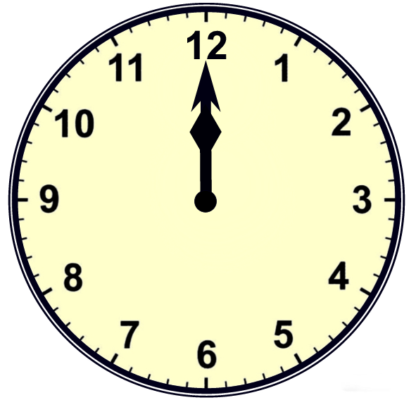
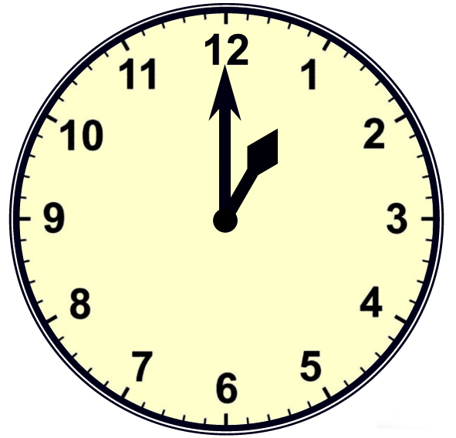
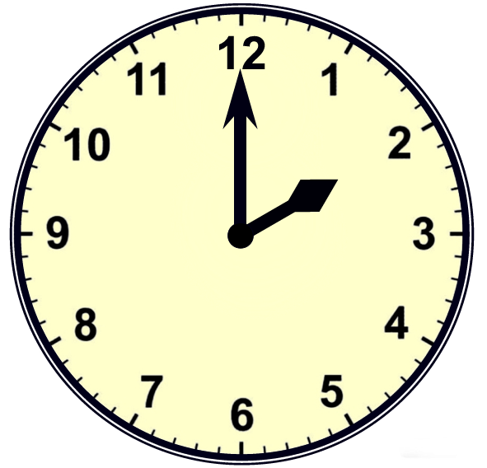
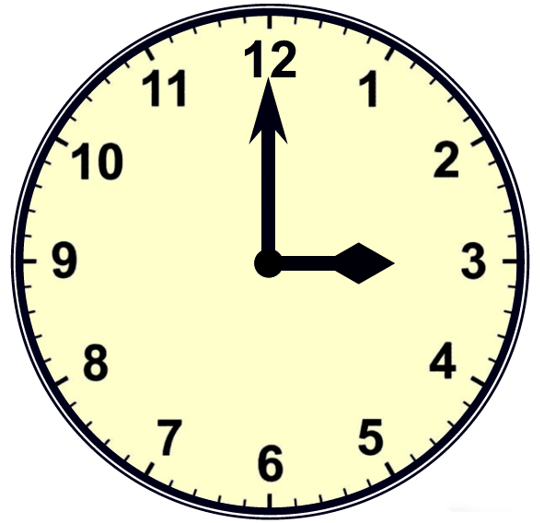
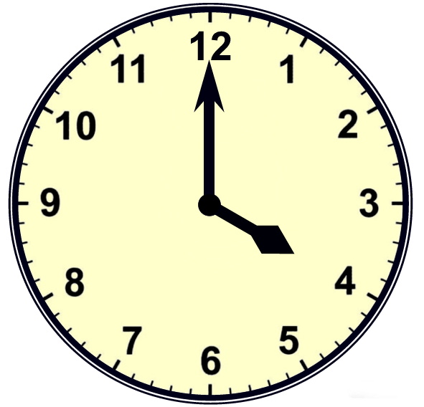
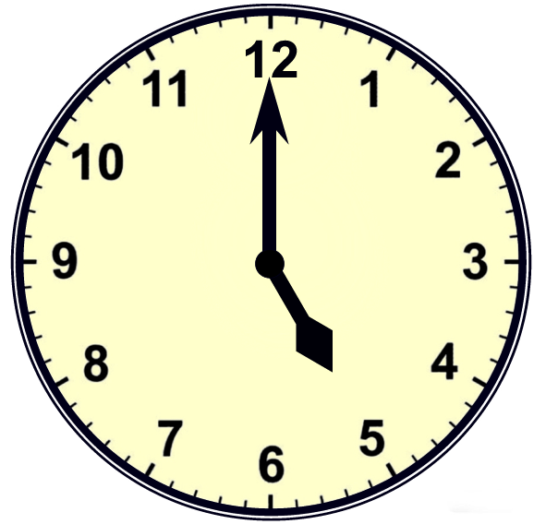
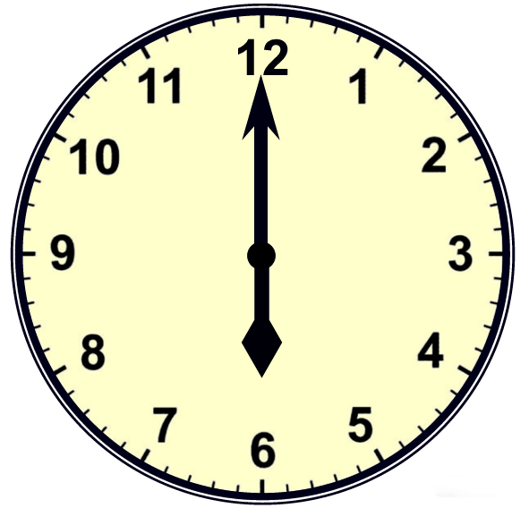
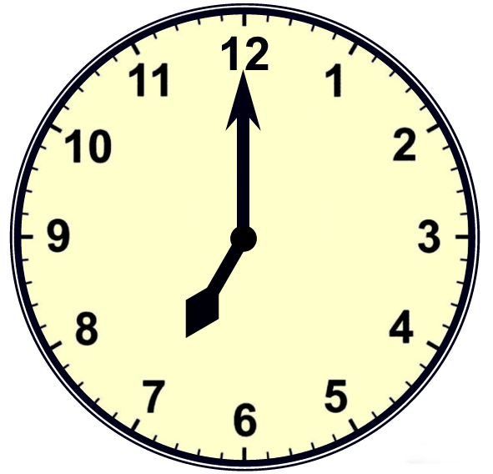
©2006 www.firstschoolyears.com
©2006 www.firstschoolyears.com
©2006 www.firstschoolyears.com
©2006 www.firstschoolyears.com
©2006 www.firstschoolyears.com
©2006 www.firstschoolyears.com
©2006 www.firstschoolyears.com
©2006 www.firstschoolyears.com
Time Cards

Time Cards

Time Cards

Time Cards

Time Cards

Time Cards

Time Cards

Time Cards

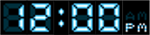



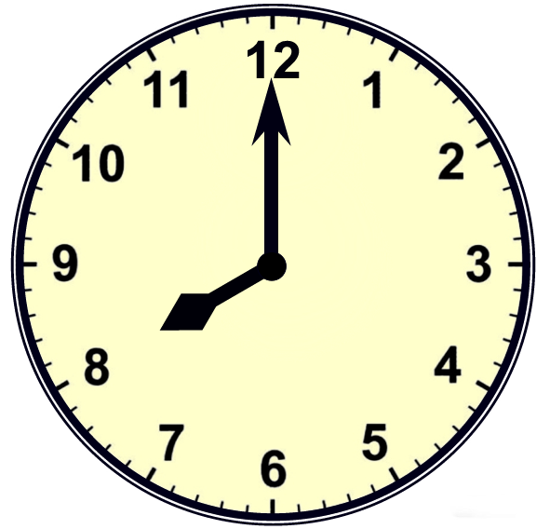
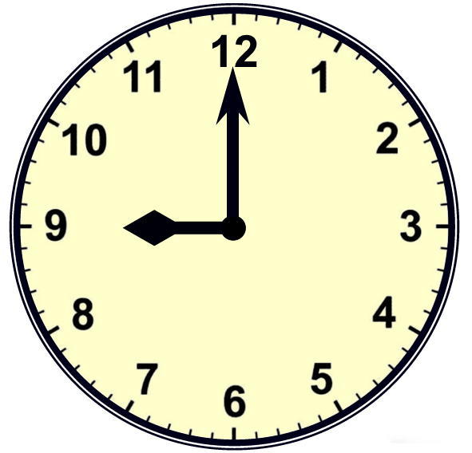
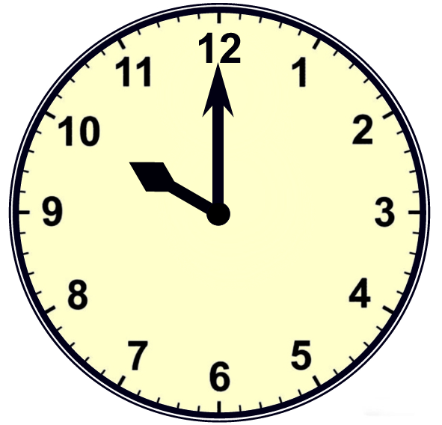
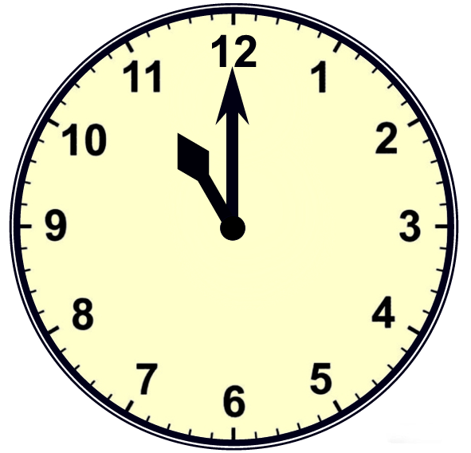
©2006 www.firstschoolyears.com
©2006 www.firstschoolyears.com
©2006 www.firstschoolyears.com
©2006 www.firstschoolyears.com
©2006 www.firstschoolyears.com
©2006 www.firstschoolyears.com
©2006 www.firstschoolyears.com
©2006 www.firstschoolyears.com
Time Cards
Time Cards
Time Cards
Time Cards
Time Cards
Time Cards
Time Cards
Time Cards






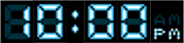
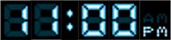
©2006 www.firstschoolyears.com
©2006 www.firstschoolyears.com
©2006 www.firstschoolyears.com
©2006 www.firstschoolyears.com
©2006 www.firstschoolyears.com
©2006 www.firstschoolyears.com
©2006 www.firstschoolyears.com
©2006 www.firstschoolyears.com
Time Cards
Time Cards

Time Cards

Time Cards

Time Cards

Time Cards

Time Cards

Time Cards

12 o’clock
1 o’clock
2 o’clock
3 o’clock
4 o’clock
5 o’clock
6 o’clock
7 o’clock
©2006 www.firstschoolyears.com
©2006 www.firstschoolyears.com
©2006 www.firstschoolyears.com
©2006 www.firstschoolyears.com
Time Cards

Time Cards

Time Cards

Time Cards

8 o’clock
9 o’clock
10 o’clock
11 o’clock

